Polar Aerosol Optical Depth

Guide to the compilation of metadata

Version 1.0

Index

1. Introduction 2

1.1 Organization of records 3

2. Part I - Registration 4

3. Part II - Record Creation 6

4. Part III - Metadata Compilation 7

4.1 Identification Info 7

4.1.1 Citation Identifier 8

4.1.2 Point of contact 9

4.1.3 Maintenance 9

4.1.4 Keywords and controlled vocabularies 10

4.1.5 Resource constraints 13

4.1.6 Aggregation information 14

4.1.7 Spatial resolution, language and topic category 14

4.1.8 Extent 15

4.2 Reference System Information 16

4.3 Distribution information 16

4.4 Data quality info 17

4.5 Contact (metadata) 18

5. Part IV - Associated resources 19

5.1 Add a link 19

5.1.1 Add link to PNRA Portal Project. 20

5.2 Add a dataset or any other generic file 20

5.3 Adding an image 22

5.4 Link between records 22

6. Part V - Saving Record 23

6.1 Record Management 23

# 

# 1. Introduction

This manual is intended to be a guide for compiling metadata and managing metadata records in the GeoNetwork system, open source software used as a platform for cataloguing metadata in the Polar-AOD project. The system is based on the principles of OPEN SCIENCE promoting free science, aimed at sharing scientific material, and FAIR (findability, accessibility, interoperability, reusability) data.

The use of a standard format for metadata (ISO 19115) and controlled vocabularies guarantees the homogeneity of records among the various nodes, which through a harvesting process are collected and made accessible to the scientific

To each record produced GeoNetwork assigns a UUID code. The UUID, a universal unique identifier, ensures that the metadata is searchable and traceable to the NADC portal.

## 1.1 Organization of records

We offer below suggestions on how records can be organized in the catalogue, remembering that each case is specific and depends heavily on how the datasets/data are structured, organized, and acquired.

It is important to try to define as much as possible a logical-scientific sense for the creation of the records with respect to the data you have. Collecting metadata in a sensible way makes it easier for those who search for it within the catalogue and at the same time can make it easier for those who compete the task to create the records.

For ease, it is possible to group a set of several parameters within the same record.

In the case of data collections, metadata can be grouped by:

- CAMPAIGN:

record 1: acquisition of x,y,z during XX Antarctic expedition.

record 2: acquisition of x,y,z during XI Antarctic expedition

record 3: acquisition of x,y,z during XII Antarctic expedition

- GEOGRAPHICAL AREA:

record 1: acquisition of x,y,z at mario zucchelli in 2020

record 2: acquisition of x,y,z at concord in 2020

NB. In case the project is still in its early stages or you do not yet have datasets to describe with specific records, it is still important to create a record with the information/metadata that relates to the **project** in general (e.g., place and period of execution, the parameters to be acquired etc).

# 2. Part I - Registration

Access the top-level node of Polar-AOD:

<https://bo.isp.cnr.it/geonetwork/polaraod/>

For information about the system or special requests, you can write to the e-mail address at info@polaraod.net.

Click at the top right on **Sign In** and then on **Create an account.**

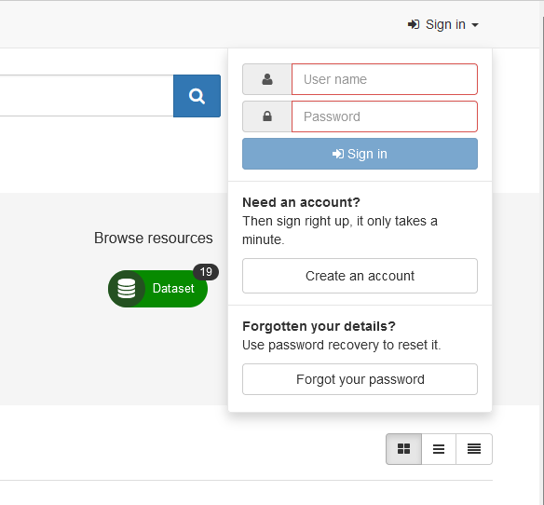

On the following page, fill in the *Name, Surname, Email* and *Organization* fields (the right column Address is optional) and choose Editor in the drop-down of the *Requested profile* field.

The **Editor** profile gives the ability to create metadata while the *Registered User* profile is limited to viewing only.

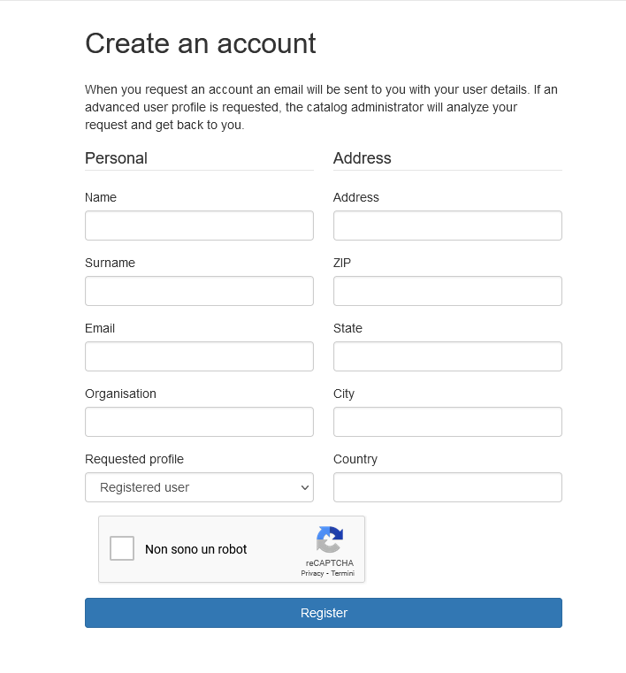



Check the mailbox of the e-mail specified during registration and verify receipt of an e-mail from the corresponding node, in which **username** and **password** for first access are indicated.

The system automatically registers the user with the *Registered User* profile (viewing metadata only) it will then be necessary to wait for activation by the profile administrator in the *Editor* mode (viewing and editing), which will allow the compilation and management of records.

# 3. Part II - Record Creation

To enter a new metadata, first log in by clicking on the "**Sign in**" button in the upper right corner.

Return to the home page and click on "**Contribute > Add new record**".

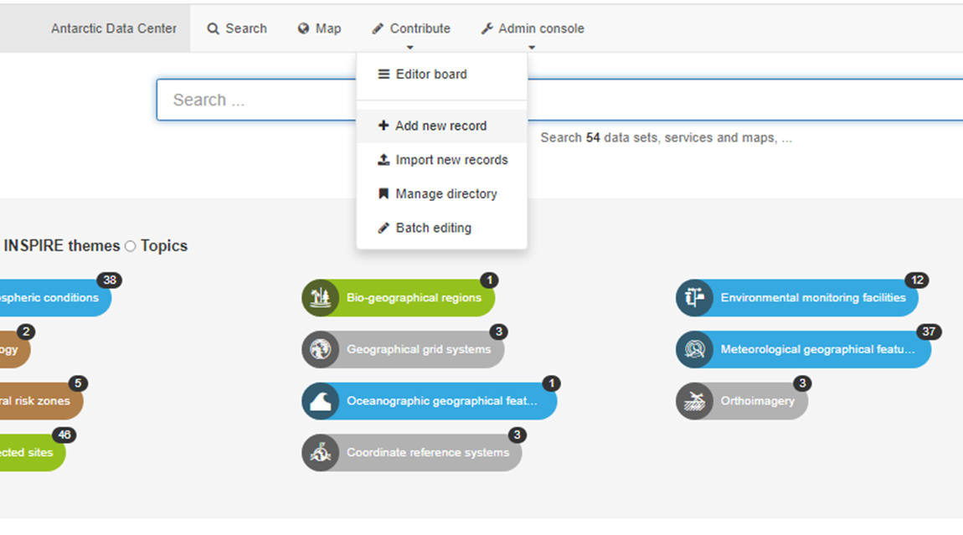

On the screen that opens, choose the template "**TEMPLATE for DATASETS**"

and click on the green "**Create**" button.

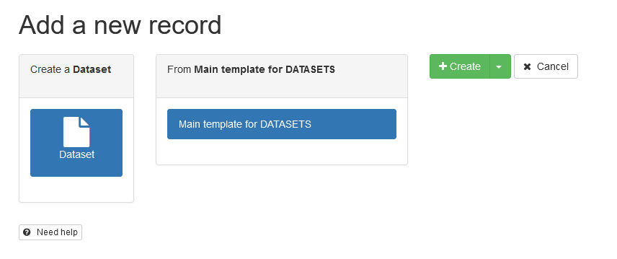

This will then open a **template** page with predefined fields to be filled in with metadata. Filling in all the entries allows the record to be validated for the ISO19115 and INSPIRE standard.

# 4. Part III - Metadata Compilation

The page that opens is a form of information to be filled out divided into the following sections and subsections:

* **Identification Info**
  + Citation identifier
  + Point of contact
  + Resource constraints
  + Aggregation information
  + Spatial resolution
  + Extent
* **Reference System Information**
* **Distribution Information**
  + Distribution format
* **Data quality info**
  + Domain consistency
  + Lineage
* **Contact**

The structure incorporates part of the ISO 19115 metadata standard schema. This schema is designed for the collection of information pertaining to a resource that has a temporal and geographic reference.

A resource is typically defined as a dataset.

A dataset can be a single file, a compressed archive containing multiple files, files uploaded to a platform (e.g., Zenodo, Hyrax, ERDDAP, its own FTP server, etc...) or other types of data.

Below is a description of the items present and an example of compilation:

## 4.1 Identification Info

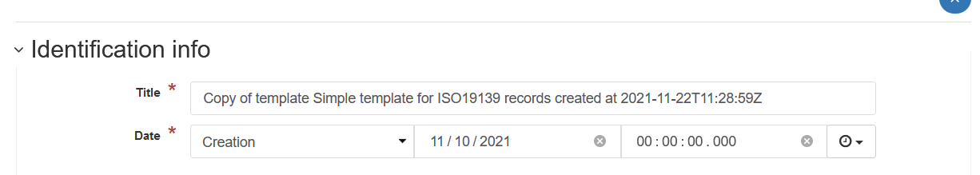

**Title**: Name of the resource you want to describe.

**Date**: A generic date whose meaning is chosen from the drop-down menu. In the example image we chose to indicate the date of Resource Creation at 11/10/2021. This date refers to the dataset we are describing.

## 4.1.1 Citation Identifier

**Code:** Identification code of the resource described. If you have a DOI enter it here otherwise the system automatically inserts the link that refers to itself.

Examples of correct completion of the Code field:

1. If you own a DOI:

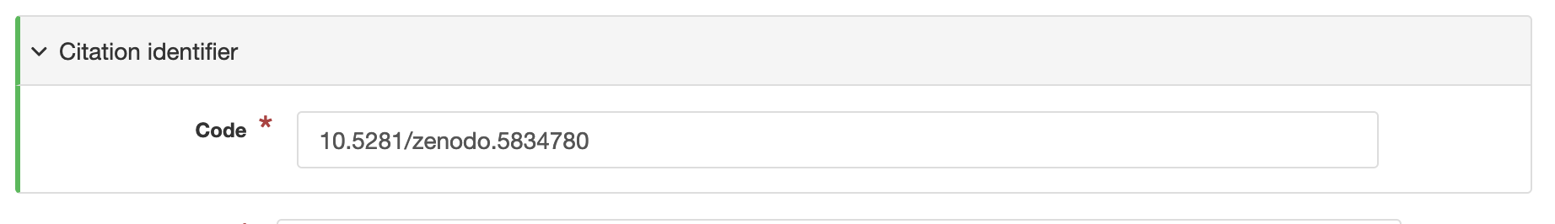

1. If you do not own a DOI:

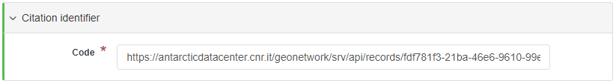

NOTE: In the case (2.) where the field is blank for some reason, proceed as follows:

Write the URL of the metadata itself like this:

[https://antarcticdatacenter.ENTE.it/geonetwork/srv/eng/catalog.search#/metadata/](https://antarcticdatacenter.ente.it/geonetwork/srv/eng/catalog.search#/metadata/)<file-identifier>



where <*file-identifier*> should be replaced with the alphanumeric value found in the pre-filled File *identifier* field further down the screen, like this:

[https://antarcticdatacenter.ENTE.it/geonetwork/srv/api/records/fdf781f3-21ba-46e6-9610-99e7f25878e9](https://antarcticdatacenter.ente.it/geonetwork/srv/api/records/fdf781f3-21ba-46e6-9610-99e7f25878e9)

Identification Info

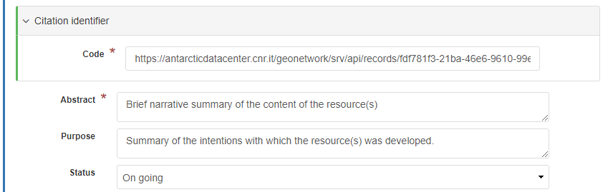

**Abstract:** A brief description of the content of the resource

**Purpose:** The purpose for which the resource was developed

**Status:** The status of the resource

## 4.1.2 Point of contact

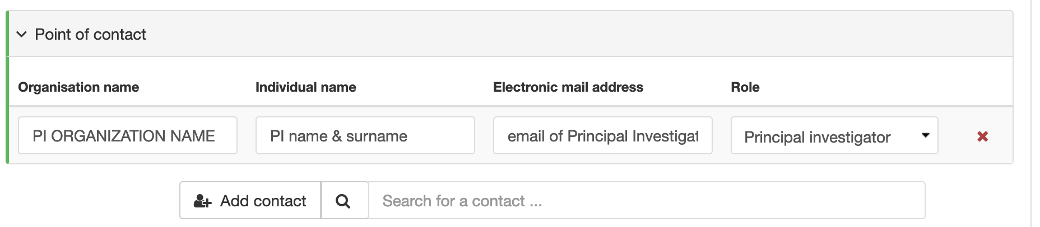

The Point of contact tab allows you to specify all the people involved in the development of the resource.

Each person is described by four attributes:

**Organization name**: Name of the person's point of contact institution.

**Individual name**: First and last name of the person

**Electronic mail address**: E-mail address of the person (preferably institutional)

**Role**: Role assumed by the person in relation to the resource we are describing

Possible roles are:

● Author: Party who created the resource.

● Custodian: Party who accepts responsibility for the data and ensures appropriate care and maintenance of the resource

● Distributor: Party who distributes the resource

● Originator: Party who created the resource

● Owner: Party who owns the resource

● Point of contact: Party that can be contacted to gain knowledge or acquire the resource

● Principal researcher: Party responsible for gathering information and conducting research

● User: Party who uses the resource

To add new people, click on the **Add contact** button

## 4.1.3 Maintenance

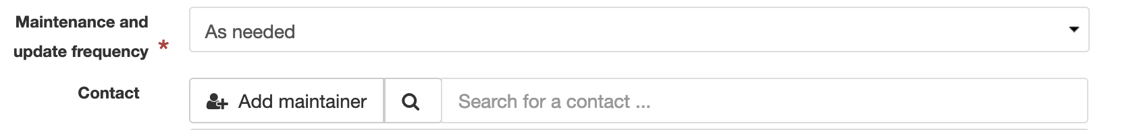

These two fields indicate how often the resource is maintained and updated and who is responsible for doing so (the maintainer).

The **Add maintainer** button brings up a Point of contact tab with the same information as described above.

## 4.1.4 Keywords and controlled vocabularies

The following section is about the keywords you want to assign to the resource you are describing, and they are grouped into the following controlled vocabularies:

* SCAR - Composite Gazetteer of Antarctica (CGA)
* GEMET - INSPIRE themes
* GCMD - Science Keywords
* GCMD - Providers
* PNRA project
* Programs and Initiatives

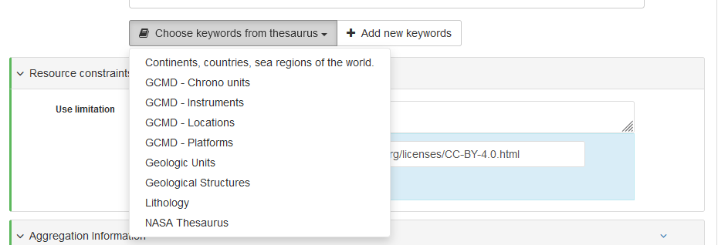

Using the Choose keywords from thesaurus button, you can choose to add additional vocabularies to the record.

Controlled vocabularies are used to unambiguously describe the resource using words whose definition is unambiguous and controlled.

For example, if I decide to use the keyword **AEROSOL** from the **GCMD - Science Keywords vocabulary**, I implicitly refer to the definition of AEROSOL contained in that vocabulary ([see definition](https://gcmd.earthdata.nasa.gov/KeywordViewer/scheme/Earth%20Science/2e5a401b-1507-4f57-82b8-36557c13b154?gtm_keyword=AEROSOLS&gtm_scheme=Earth%20Science)).

**SCAR - Composite Gazetteer of Antarctica (CGA)**



The [SCAR Composite Gazetteer of Antarctica](https://data.aad.gov.au/aadc/gaz/scar/) (CGA) vocabulary, offered by the SCADM, contains information such as codes and geographic coordinates that describe places found in the Antarctic territory.

**GEMET, INSPIRE themes**



It is a vocabulary controlled by the European community and contains all spatial data themes as defined by INSPIRE. It is used by Geonetwork as a search criterion by subject area on the home page.

INSPIRE (Infrastructure for Spatial Information in Europe) is an infrastructure for spatial information in the European Community, the purpose of which is to collect spatial information from member states in a single portal, accessible here: [INSPIRE Geoportal (europa.eu)](https://inspire-geoportal.ec.europa.eu/). The information in this portal is categorized with the keywords contained in the vocabulary under review.

**GCMD - Science Keywords**

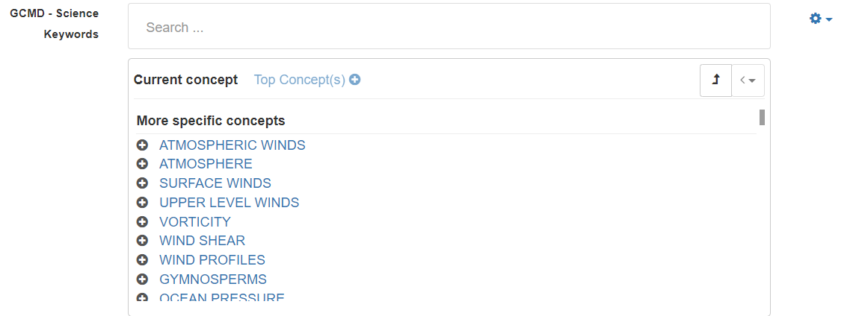

The [GCMD - Science Keywords](https://gcmd.earthdata.nasa.gov/KeywordViewer/scheme/Earth%20Science) vocabulary is controlled by NASA and includes all concepts and terms that relate to science and nature and their different areas.

You can choose keywords from this vocabulary either by typing in the "Search..." bar or by clicking on the generic concepts in blue in the tab just below the bar. As you click on a concept, more and more specific concepts appear. When you want to add a concept as a keyword you must click on the "+" button to the left of the word.

The use of such vocabulary is encouraged by the interoperability guidelines of YOPP - Data portal.

**GCMD - Providers**

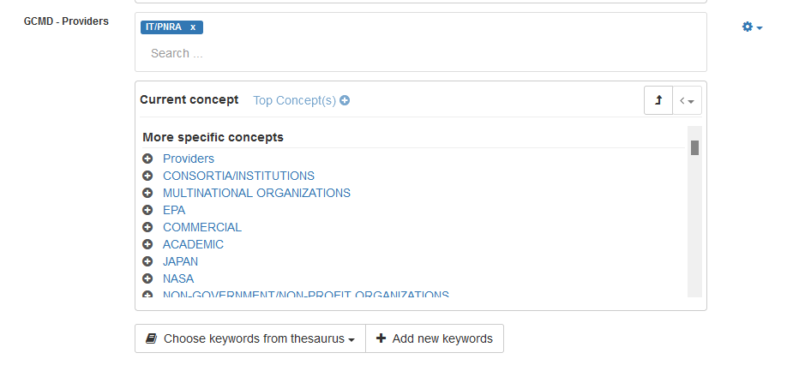

The [GCMD - providers](https://gcmd.earthdata.nasa.gov/KeywordViewer/scheme/providers) is controlled by NASA and contains definitions entities, research institutes, universities, projects and more. It appears pre-filled with the keyword IT/PNRA.

**PNRA project**



The vocabulary contains acronyms and code for projects carried out under PNRA. We suggest linking the metadata to the corresponding [project sheet](https://www.pnra.aq/it/index-projects) on the PNRA portal, following the guide: **5.1.1 Adding link to PNRA Portal Project Sheet**.

**Programs and Initiatives**



The vocabulary contains the names of national and international initiatives and programs in which research projects are involved. You can specifically add names of initiatives or programs by writing an email request to ***info_nadc@pnra.aq.***

**Free text keywords**



In this field you can add keywords not contained in the controlled vocabularies. Enter them separated by commas.

## 4.1.5 Resource constraints

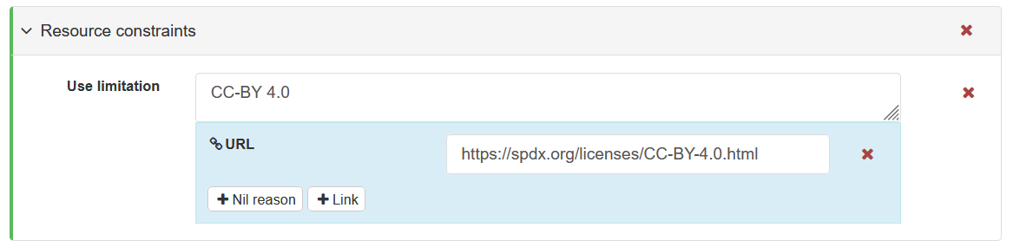

The resource constraints tab allows you to specify the type of license under which the data is protected. Enter the license name in the text field (e.g., CC-BY 4.0) and a link to the license description in the URL field.

If you are not sure which license to use you can refer to the infographic below.

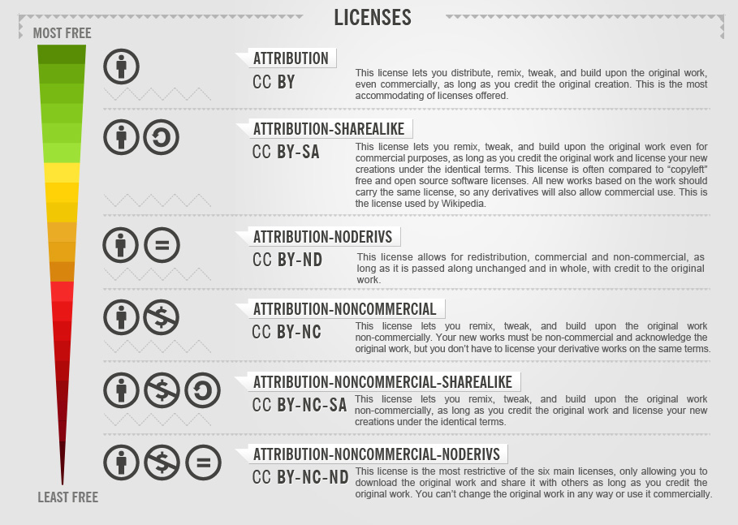

After identifying the license you want to use, you can find the relevant link from this list: <https://spdx.org/licenses/>

## 4.1.6 Aggregation information

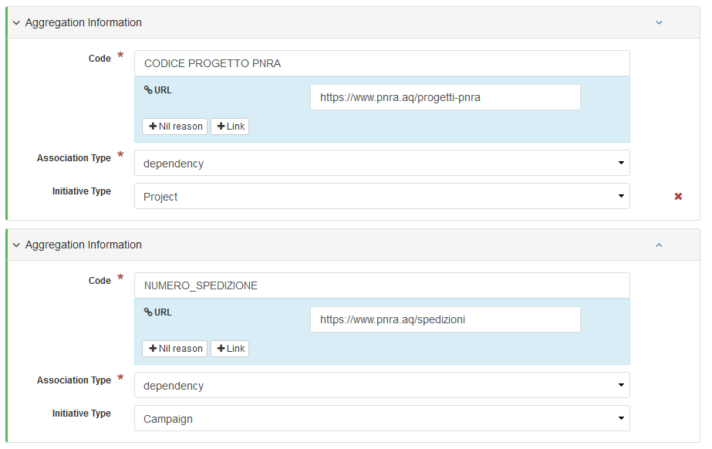

In these fields, enter the **PNRA project code** and **expedition number**, both of which are linked to the reference link, if any, on the portal [pnra.aq](https://www.pnra.aq/).

If this information is not available, the entire field can be deleted using the red X button found inside the gray box at the height of the field title of interest.

## 4.1.7 Spatial resolution, language and topic category

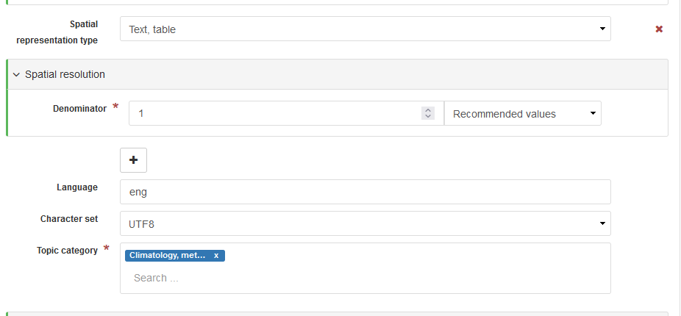

**Spatial representation type:** the method used to represent the spatial information in the resource. For example, if we are describing a tabular dataset and have entered the spatial information in the form of latitude and longitude as table columns, we can choose the "Text, table" method. By holding the mouse over the possible choices in the drop-down menu, a description of the various methods can be displayed.

**Spatial resolution > Denominator:** If the dataset includes a map, enter the scale factor of the maps here otherwise leave 1.

**Language:** The language in which the resource being described is developed.

**Character set:** indicates the character encoding used for the resource. If you are not sure, leave UTF8.

**Topic category:** the ISO topic categories with which you want to categorize the resource. This field is used by Geonetwork to group resources into macro categories then displayed on the home page just below the search bar:

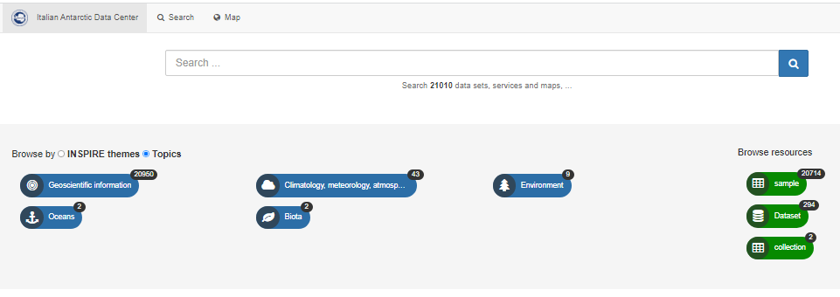

## 4.1.8 Extent

**Geographic bounding box**

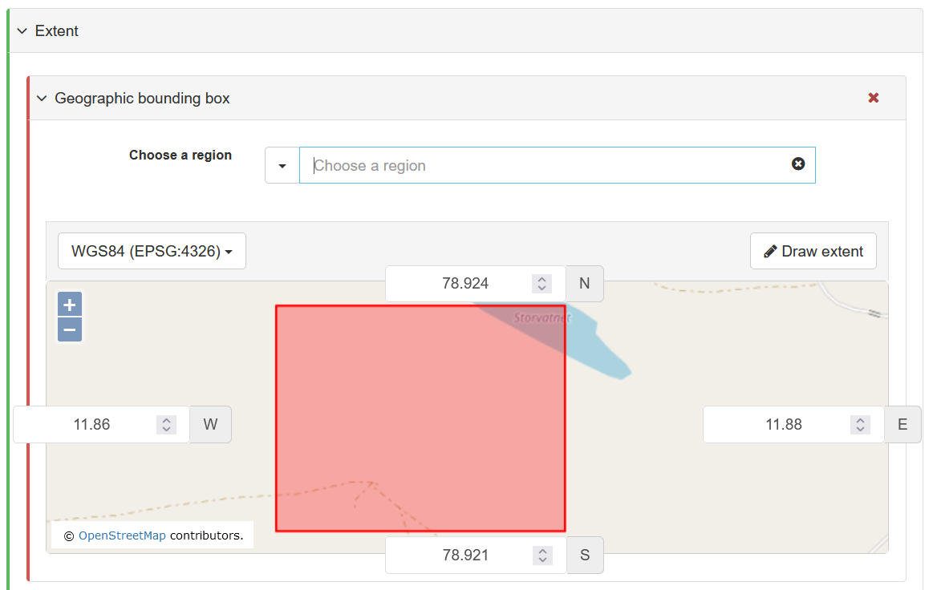

In this tab you can specify the area or location referenced by the resource you are describing by entering geographic coordinates according to the WGS84 reference system.

**Temporal extent**

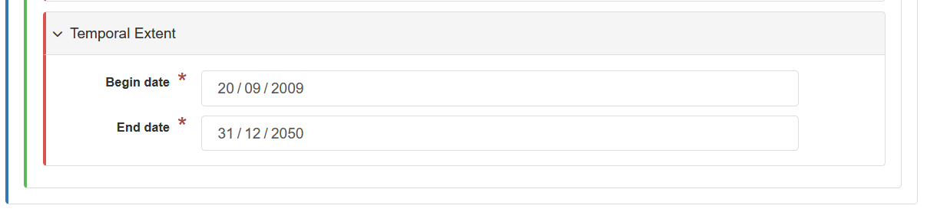

in this tab you can indicate the time extension of the resource, typically the date of the first and last measurement.

**Begin date**: Date of the first measure

**End date**: Date of the last measure

## 4.2 Reference System Information

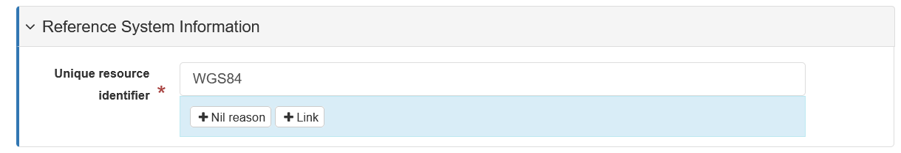

This field describes the reference system used in the dataset for spatial measurements.

The field is pre-filled with the value "WGS84," which stands for World Geodetic System - 1984. It is a geodetic geographic coordinate system that is a mathematical model of the earth. GPS and NATO use this coordinate system. For more information: <https://epsg.io/4326>.

Typically latitude and longitude values are given in WGS84. If you are not sure what to enter leave the value pre-filled.

## 4.3 Distribution information

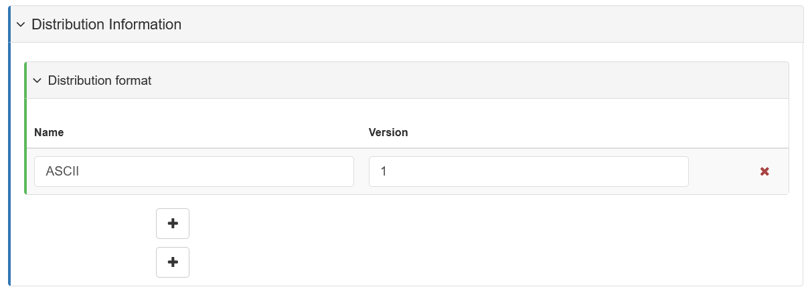

**Distribution format**

This field describes the format(s) in which the dataset is distributed.

**Name**: the name of the format

**Version**: the version of the format (if the format has no version, specify the value "1").

If you want to specify additional formats in which the dataset is distributed, click on the "+" button just below the text field.

## 4.4 Data quality info

This tab is used to specify information regarding the quality of the dataset.

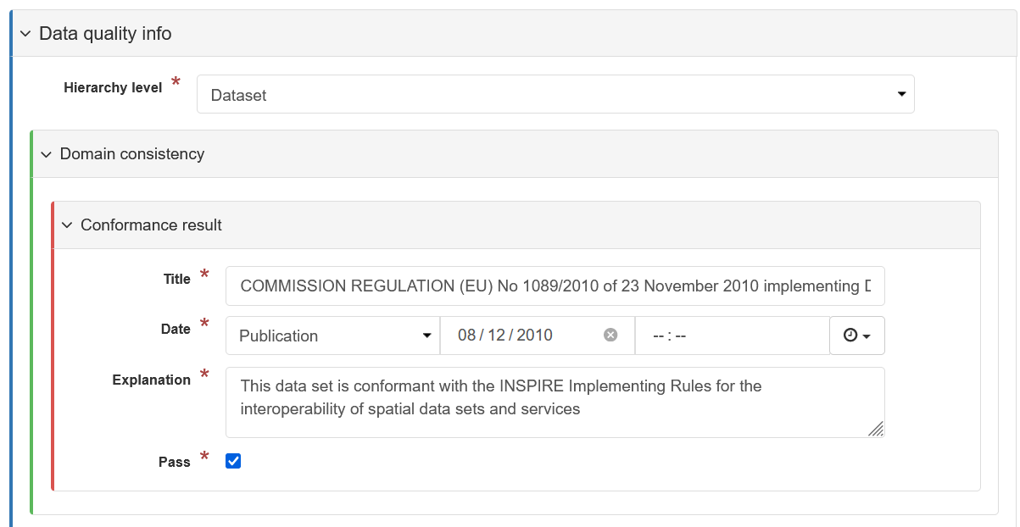

**Hierarchy level:** specifies what the information being described applies to. Geonetwork can be used to describe various types of resources, but NADC uses it to describe the "Dataset" resource. Therefore, leave this field unchanged.

**Domain Consistency & Conformance result:** Leaving this field unchanged allows INSPIRE validation.

**Lineage>Statement:** in this field describe all the steps the data go through before being saved in the dataset you are describing. How they are collected, how they are checked, whether they are normalized, whether they undergo a quality control process, etc..

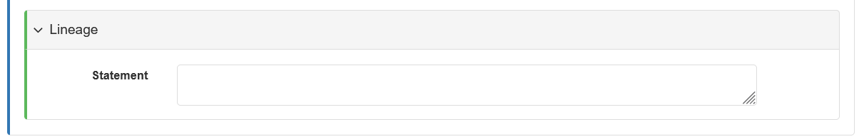

**Information on metadata itself**

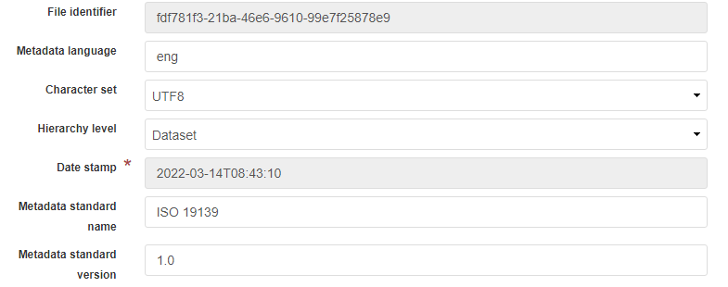

In this section there is a range of information about the format of the metadata you are writing. Leave the preset values unchanged.

## 4.5 Contact (metadata)

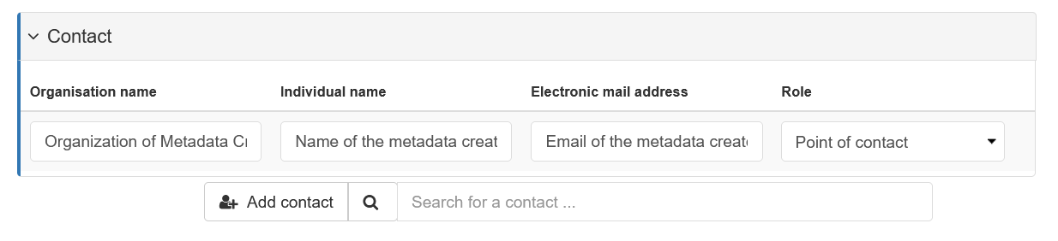

In this tab you can specify the person(s) who is in charge of managing the metadata you are writing. Fill in the same way as the points of contact for the resource.

# 5. Part IV - Associated resources

it is possible to add resources associated with the metadata, typically links to a descriptive page of the dataset or project referenced, a link to a service that distributes the dataset, or the dataset itself.

To add a resource click on the **"+ Add**" button on the **Associated resources** tab and then click on **Link an online resource** in the drop-down menu.

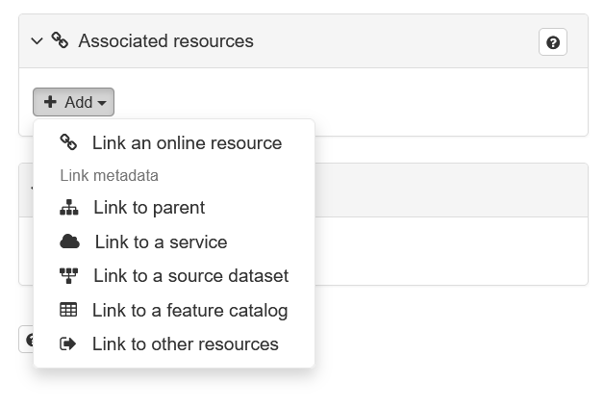

## 5.1 Add a link

On the next screen choose the **Protocol** (resource type) and paste the link to the resource in the **URL** field. You may also possibly choose other protocol types depending on the type of resource you are associating with.

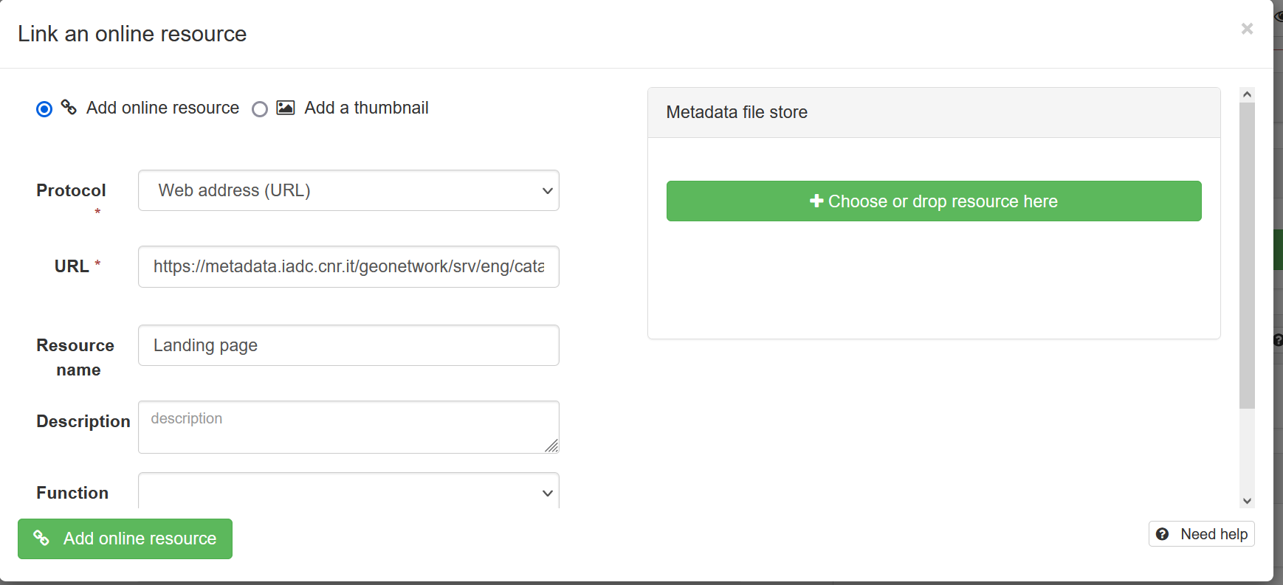

To confirm click on the green **Add online resource** button.

In the example image, the link to the metadata itself (copied from the pre-filled Code field) was inserted using the Web address protocol and the Resource name "Landing page."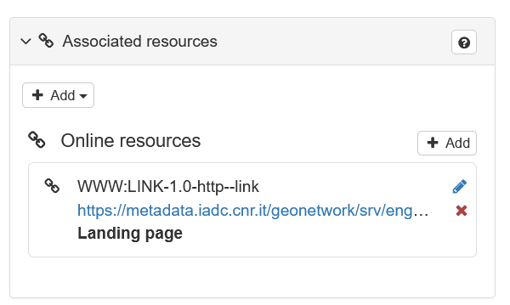

It is recommended to always include this link because it is a reference to the metadata itself used when it is uploaded to other portals.

Confirmation that the online resource has been added is the appearance of the tab containing the link just entered.

### 5.1.1 Add link to PNRA Portal Project

Follow the procedure of adding a generic link: click on the "+ Add" button on the Associated resources tab and then click on Link an online resource in the drop-down menu, choose the Protocol 'Web address (URL).

Enter in the URL field the link related to your project tab present on the[**PNRA**](https://www.pnra.aq/it/index-projects) **portal** and in ‘Resource name’ writing: ‘***acronym project* – PNRA project**’.

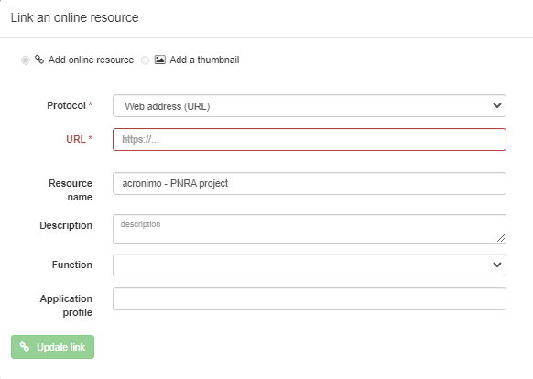

## 5.2 Add a dataset or any other generic file

You can add the dataset itself (e.g. in txt, csv, etc. format) directly into Geonetwork.

Click on the **"+ Add**" button on the **Associated resources** tab and then click on **Link an online resource** in the drop-down menu.



In the screen that appears click on the green button on the right **"+ Choose or drop resource here**" and choose the file you want to upload and confirm your choice in the system window.

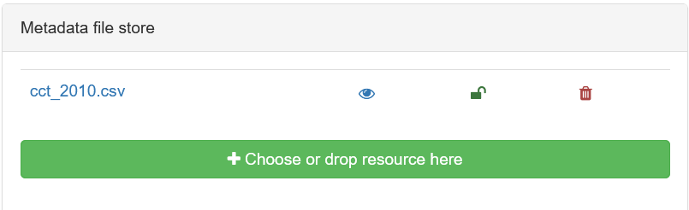

In the example image, the file cct_2010.csv was uploaded.

At this point click on the file name. The fields on the left will be populated automatically.

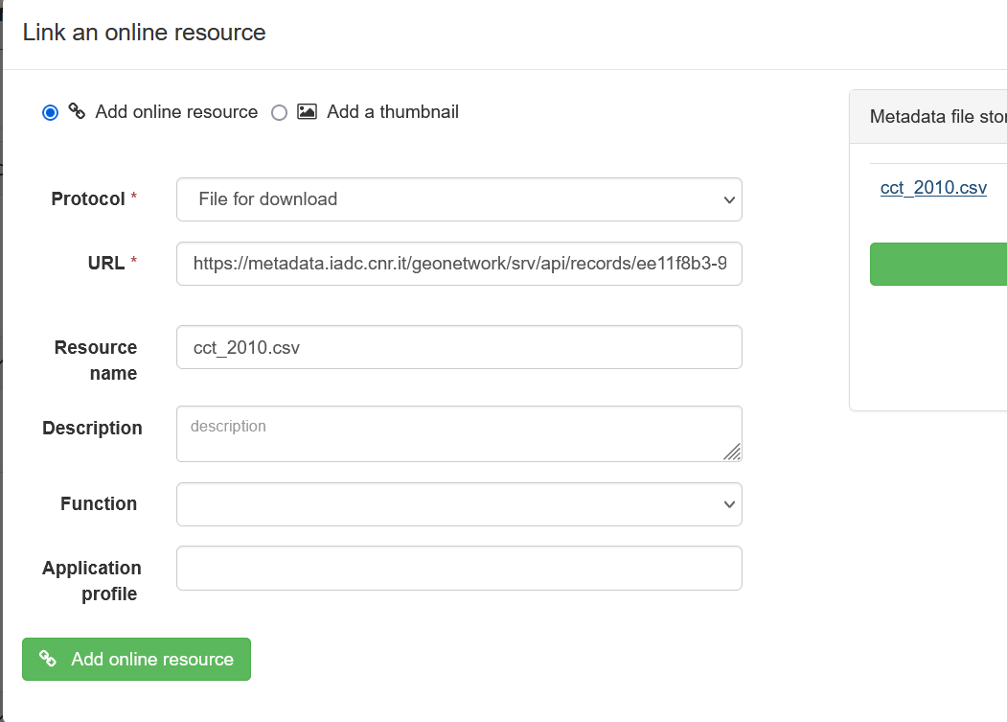

Finish by clicking on the green button: **Add online resource.**

## 5.3 Adding an image

You can choose an image for the metadata record which will appear on the catalogue home page

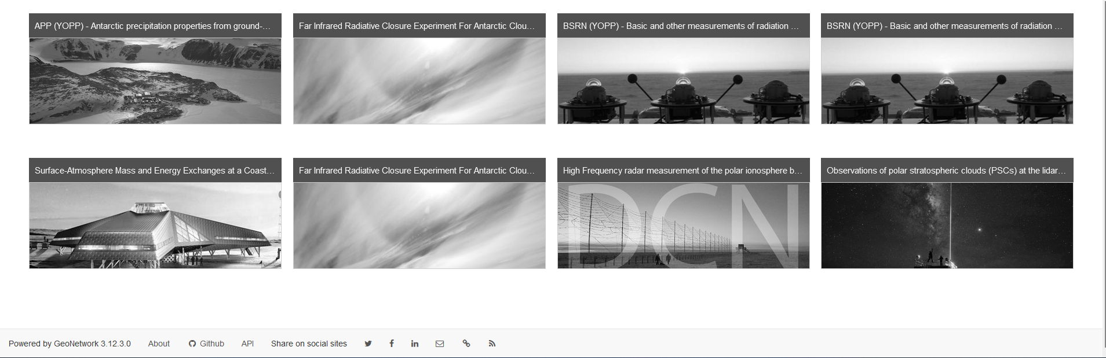

To do this click on the green button on the right **Choose or drop an image here**, choose the image, wait for it to load.

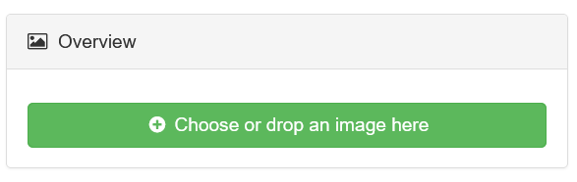

## 5.4 Link between records

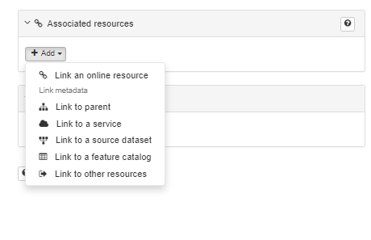

you can link different records together using the functions in the image by defining the type of relationship between the different records.

If this is the case, contact those responsible for the node to define how to use this function at **help-dati@pnra.aq**

# 6. Part V - Saving Record

you can save your metadata using the **save metadata** button**.**

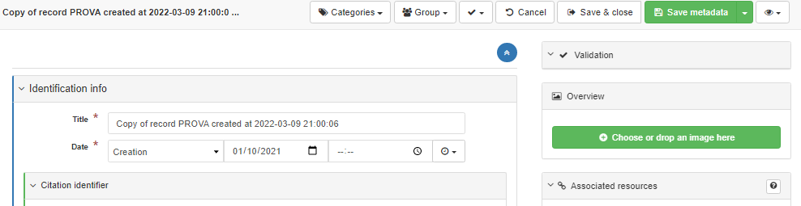

When you have finished compiling and saving, you should use the save and close button to close and return to the general **editor board** page.

PLEASE NOTE: As a result of inactivity, the system will automatically log out causing contributions to be lost if they have not been previously saved.

## 6.1 Record Management

Once records are created they can be edited, copied, or deleted



By going to **Contribute > Editor Board** it is possible to see the records that have been produced and are in the Geonetwork catalogue. Because of the limited scope of action, the PI or researcher will only be able to manage the records that he or she has created.



The icons on the right describe the actions that can be performed on the record.

**Edit**: edit the record in the editor fields

**Delete**: delete the record

**Create a child**: creates a hierarchical link of the parent - child type with another record already in the system

**Copy**: creates a copy of the record

For any information write to[***info_dati@pnra.aq***](mailto:info_dati@pnra.aq) or ***help-dati@pnra.aq***